Ebaad Ahmed

Abstract

PROCESS TO CREATE UBUNTU 24.04.2 USB FLASH DRIVE WITH ORTHANC INSTALLED READY TO BOOT A DIAGNOSTIC WORKSTATION WITH STAND ALONE IMAGE HANDLING SOLUTION.

CODE DARK USB FLASH DRIVE SETUP INSTRUCTIONS – UBUNTU 24.04.2

Table of Contents

CREATE BOOT DRIVE FROM UBUNTU ISO IMAGE 2

BOOT THE COMPUTER WITH UBUNTU ISO IMAGE 4

INSTALL UBUNTU ISO IMAGE ON USB DRIVE 2 5

POST INSTALL UBUNTU SETUP 12

Install Orthanc 12

System Control panel changes 16

Update GDM changes 21

# CREATE BOOT DRIVE FROM UBUNTU ISO IMAGE

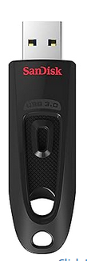

1. Required Hardware
   1. 2 32GB USB FLASH drives,
      1. DRIVE 1 UBUNTU IMAGE
      2. DRIVE 2 UBUNTU BOOT DRIVE

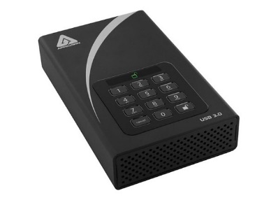

* 1. 1 APRICORN Drive (encrypted)
     1. DRIVE 3 DATA DRIVE

1. Open Chrome or any browser and paste the following link to download Ubuntu 24.04.2 iso image:

LINK: <https://nnenix.mm.fcix.net/ubuntu-releases/24.04.2/ubuntu-24.04.2-desktop-amd64.iso>

CHECKSUM:

sha256sum: d7fe3d6a0419667d2f8eff12796996328daa2d4f90cd9f87aa9371b362f987bf

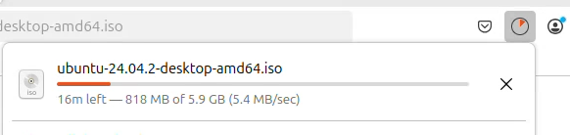

1. On a windows system download rufus from the following URL,

<https://rufus.ie/downloads/>

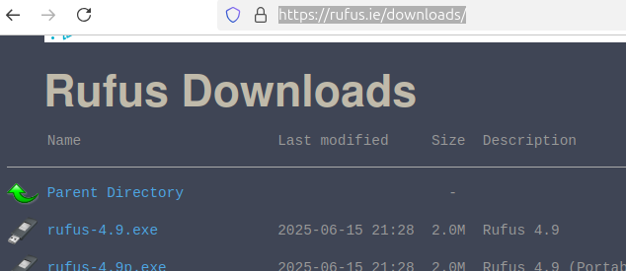

1. 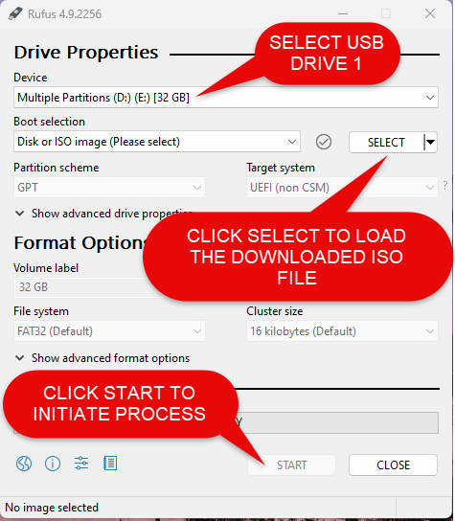Using Rufus transfer iso file to DRIVE 1 to create a bootable USB drive for UBUNTU 24.04.2
   1. Insert DRIVE 1 in a USB slot
   2. Start RUFUS and select USB DRIVE 1 as the target device
   3. Select the iso image from the directory where iso image was downloaded
   4. Leave all options as default
   5. Click START to initiate the process
2. Following status will be shown in RUFUS once the process is completed successfully

# BOOT THE COMPUTER WITH UBUNTU ISO IMAGE

1. Insert **DRIVE 1** into the PC and reboot the machine
2. Disconnect the network cable
3. Press **F12** or Esc to access BIOS settings and BOOT OPTION when rebooting
4. Select the **UBUNTU DRIVE 1** from UEFI section to as boot device
5. Press **F10** to Save BIOS settings and Esc to exit BIOS

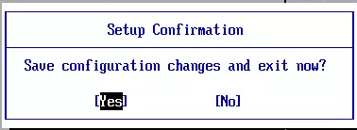

1. Select “**Try to install Ubuntu**” from the GRUB window

PC will reboot in **UBUNTU 24.04.2** install window

# INSTALL UBUNTU ISO IMAGE ON USB DRIVE 2

1. Make sure to insert **DRIVE 2** prior to starting the install process
2. Select “**Install Ubuntu**”

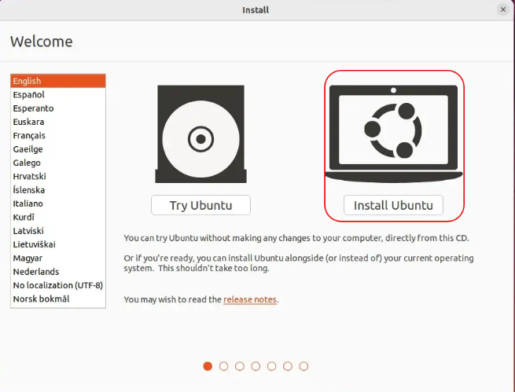

1. Select “**English**” and press “**Next”**

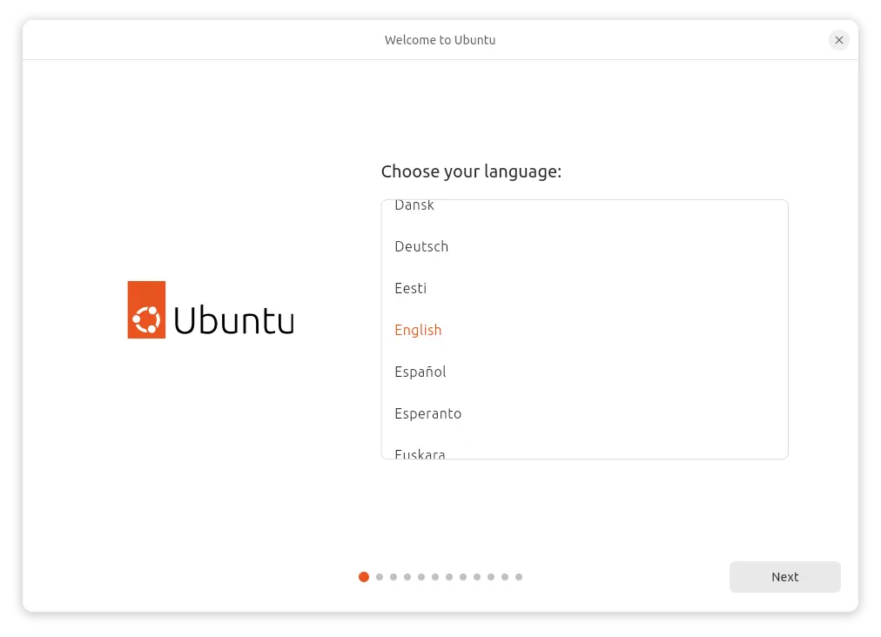

1. Accept “**Accessibility in Ubuntu**” option and select “**Next**”

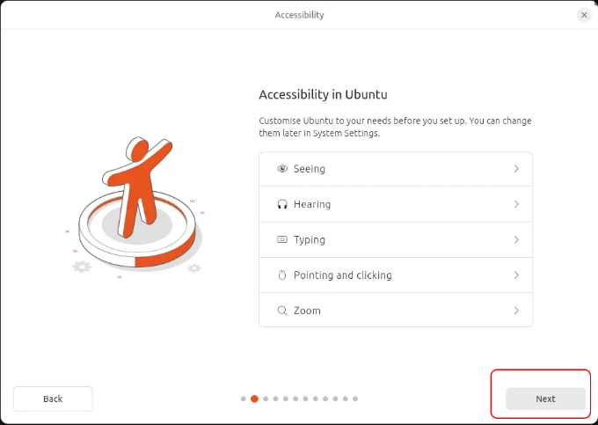

1. Select “**English (US)**” for keyboard layout and select “**Next**”

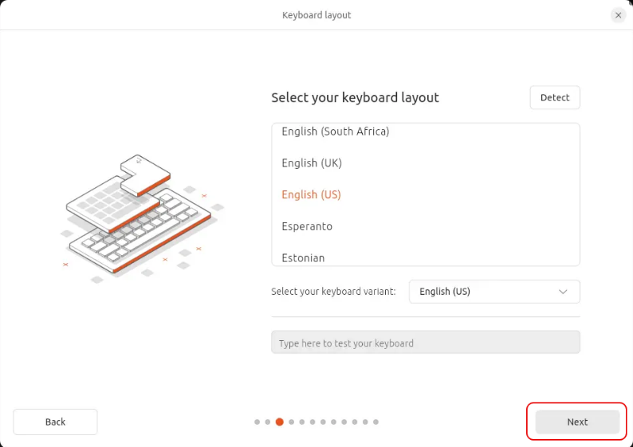

1. Select “**Do no connect to the Internet**”

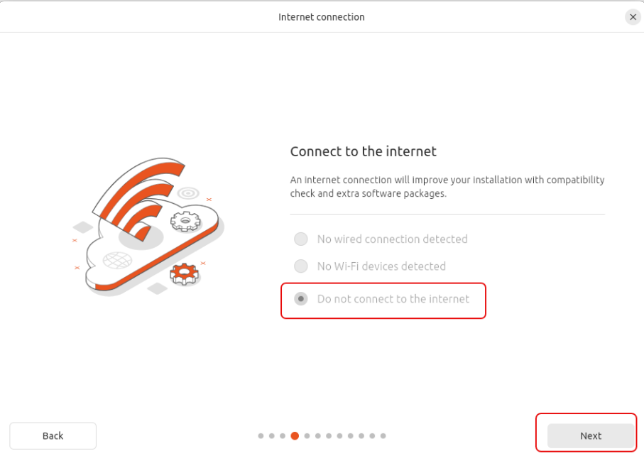

1. Select “**Install Ubuntu**” and click “**Next**”

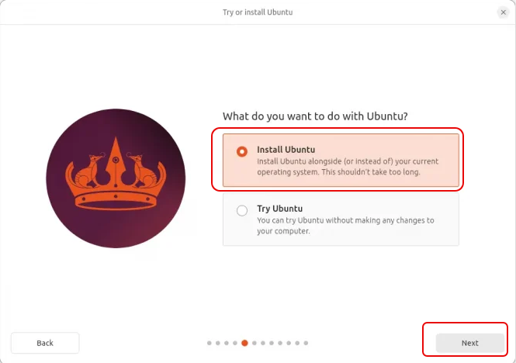

1. Select “**Interactive Installation**” and click “**Next**”

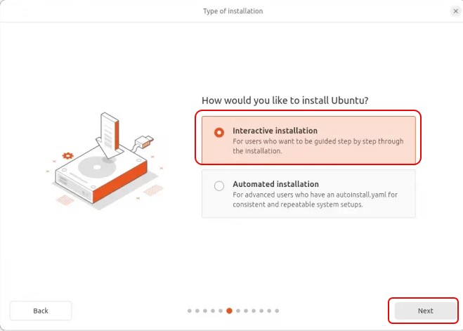

1. Select “**Extended selection**” to install all Wi-Fi and Graphics drivers and click “**Next**”

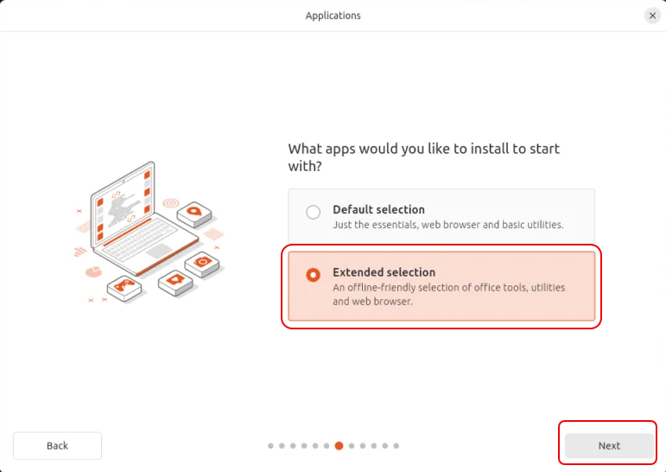

1. Select “**Erase disk and install Ubuntu**” and click “**Next**”

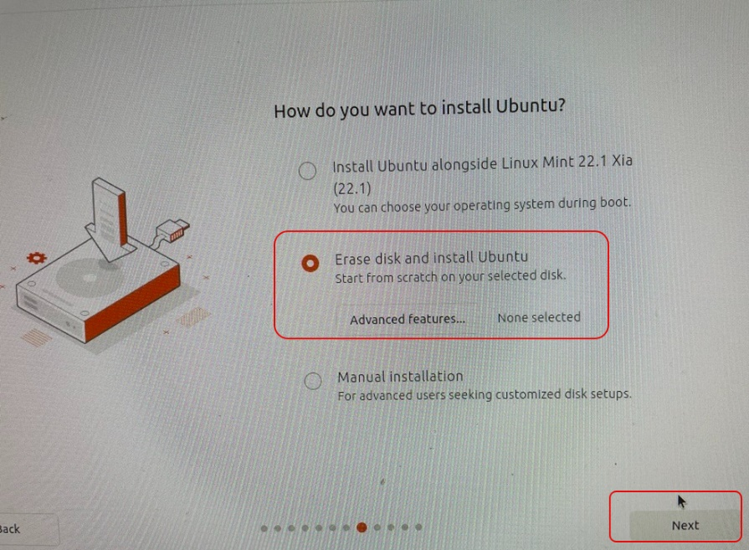

1. Select the “**DRIVE 2 sdc**” to install the new Operating System

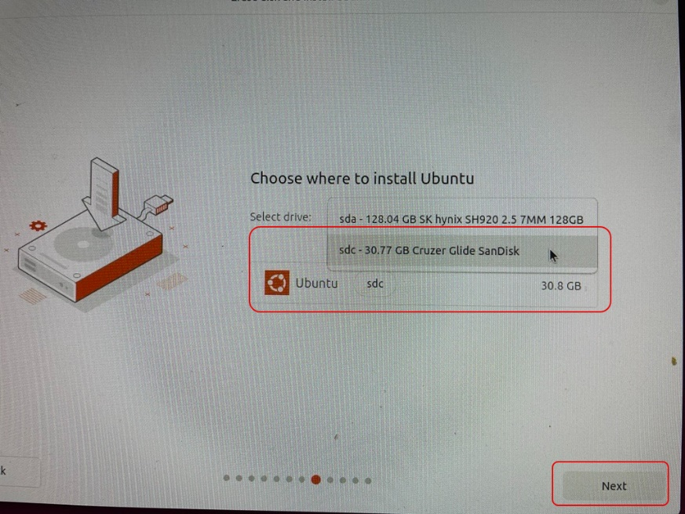

1. Fillin the fields with the information below and click Next to proceed,
   1. Your Name: **Saruman B Orthanc**
   2. Your company’s name: **orthanc**
   3. Your username: **orthanc**
   4. Password: **orthanc**
   5. Confirm Password: **orthanc**

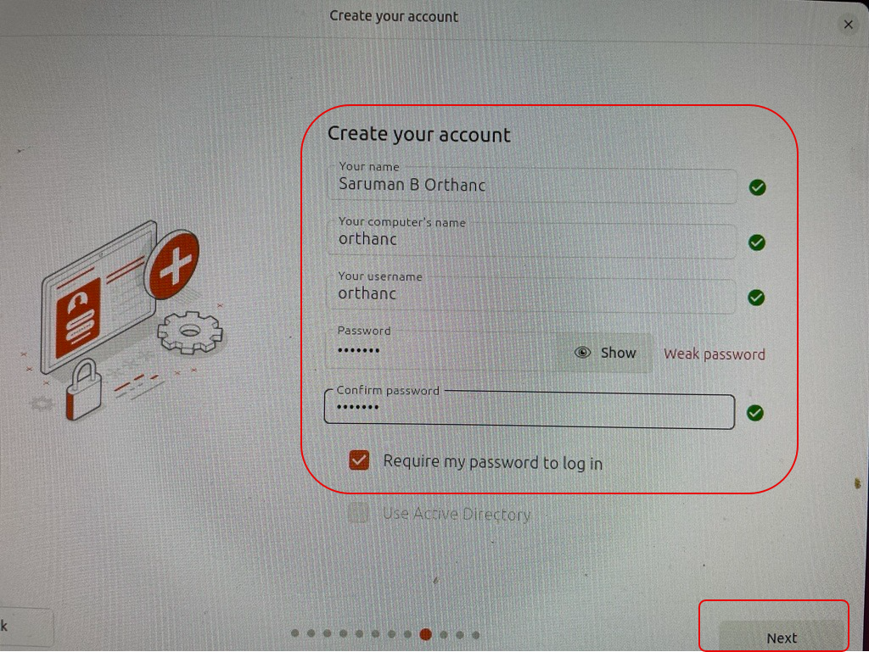

1. Select “**Time Zone**” and click “**Next**”

1. Review your choices and click “**Install**”

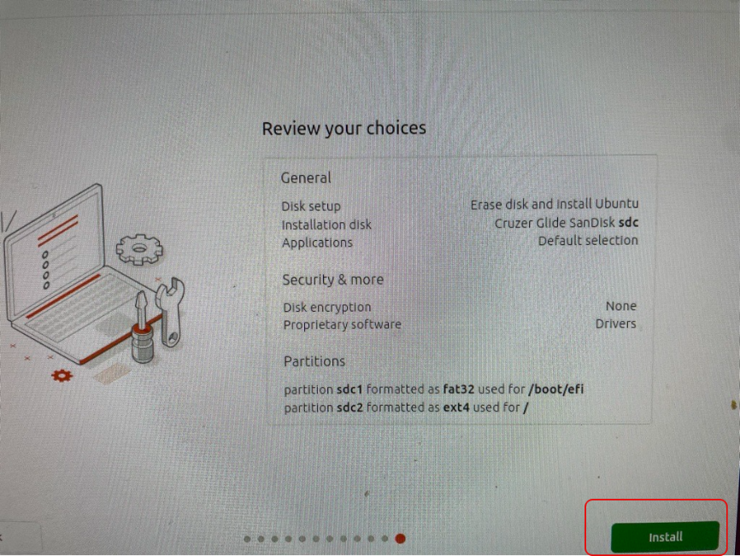

1. Upon successful completion select “**Restart now**” from the window,

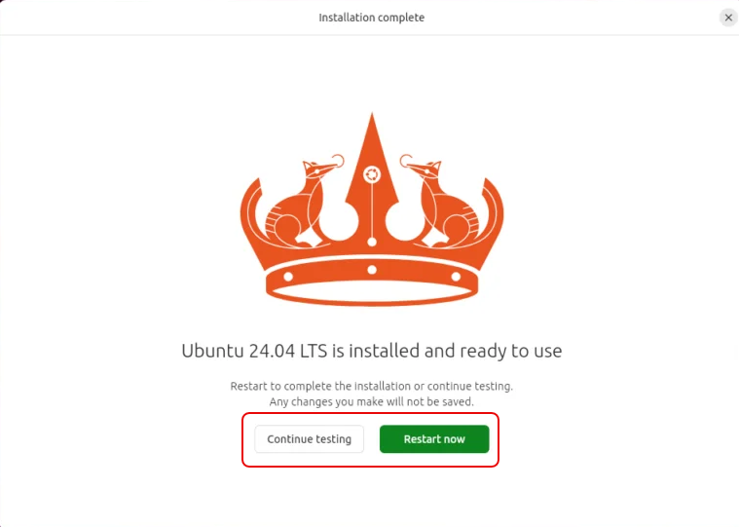

# POST INSTALL UBUNTU SETUP

## Install Orthanc

1. Insert USB **DRIVE 2** and reboot the PC
2. Make sure to go through the boot options and select Ubuntu or USB Drive from UEFI options
3. Once successfully booted Ubuntu will display the following screen, click “**Next**”to proceed,

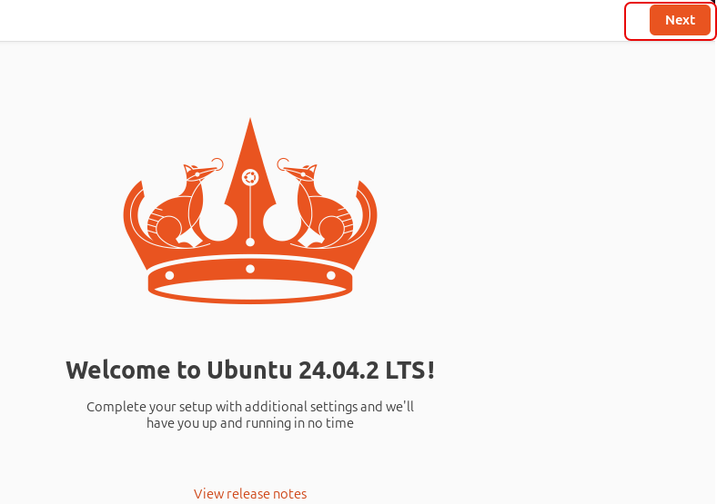

1. Select “**Skip**” to bypass the “**Ubuntu Pro**” option

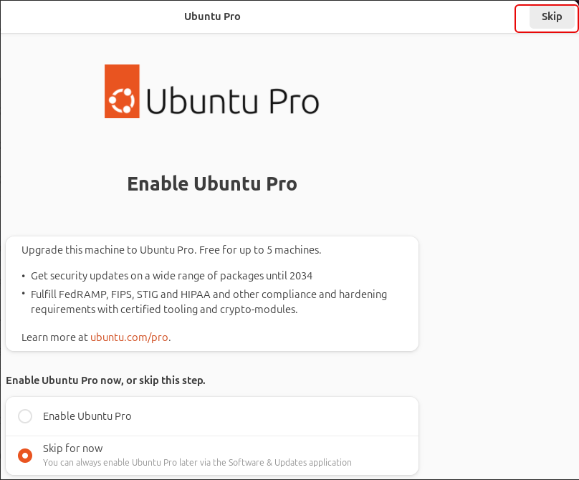

1. Click pass any other windows to get to the main Ubuntu Desktop
2. Click “Finish” to complete the process

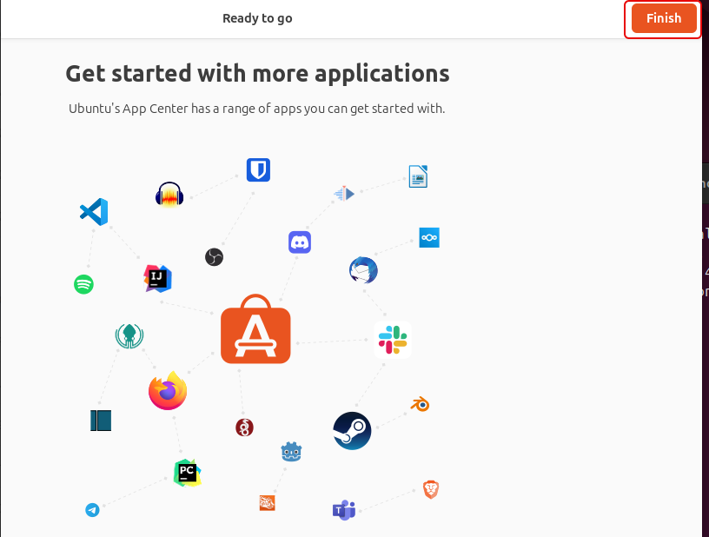

1. Connect network cable to activate the network connection
2. Right click on desktop and select “**Open in Terminal**” to access terminal window

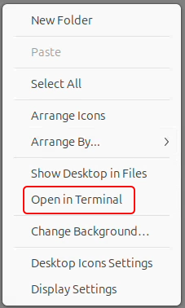

1. Run “**sudo apt update**” in terminal window and enter password when prompted, this will refresh all the installed applications

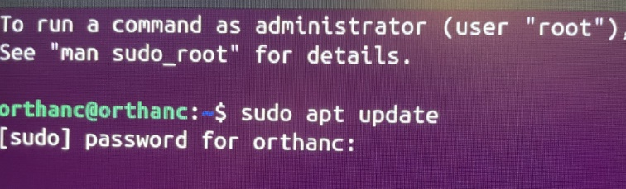

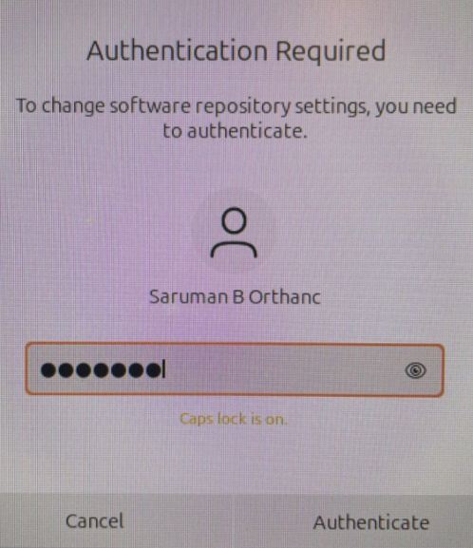

1. Enter the following commands in terminal to download the latest kp-report package to install the Code Dark and Orthanc applications
   1. Change directory to tmp

orthanc@orthanc: cd /tmp

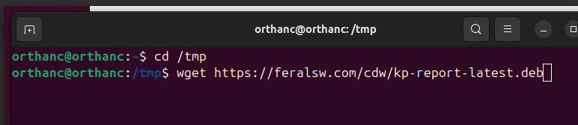

* 1. Download kp-report package

orthanc@orthanc: wget <https://feralsw.com/cdw/kp-report-latest.deb>

* 1. Install downloaded kp-report package

orthanc@orthanc: sudo apt install -y ./kp-report-latest.deb

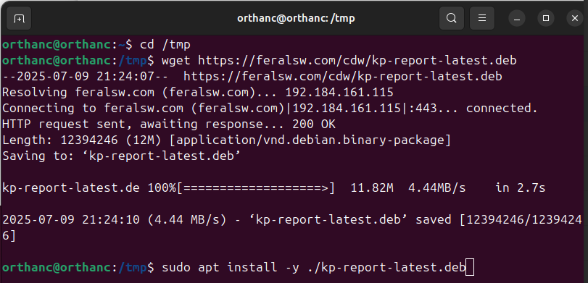

NOTE: *Ignore and dismiss all alert boxes that will then show up before things*

*finish. As you continue along delete any popups asking to install updates.*

## A screen shot of a phone AI-generated content may be incorrect.System Control panel changes

1. Click on “**Show Apps**” button to access applications menu.
2. 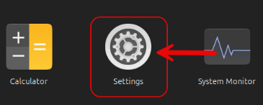Click on “**Settings**”
3. Click “**Ubuntu Desktop**”

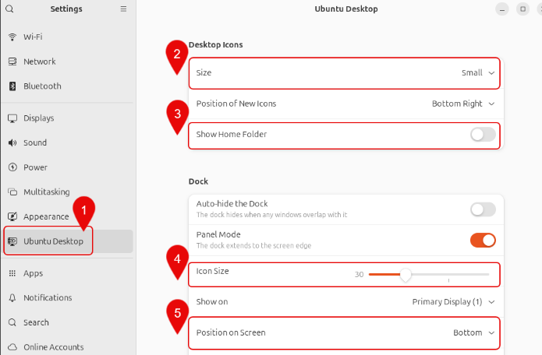

* 1. Set “**Desktop Icons**” size to “**Small**”
  2. Uncheck “**Show Home Folder**”
  3. Set task bar “**Icon Size**” to **30**
  4. “Position on **Screen**” to “**Bottom**”

1. Click “**Privacy & Security**”

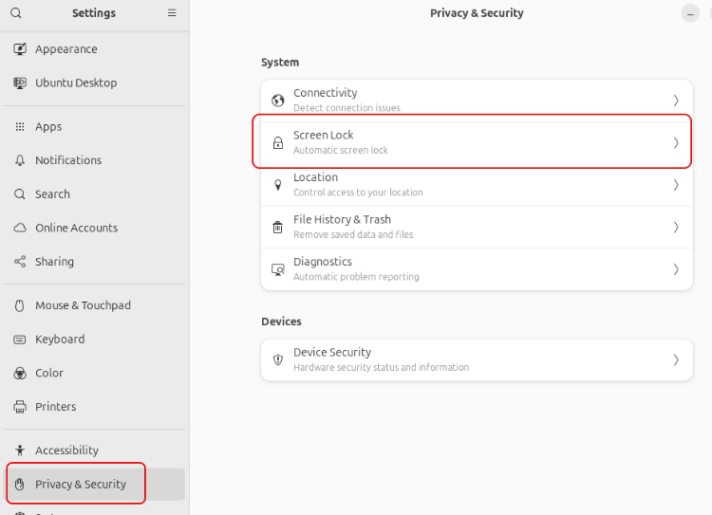

* 1. Click “**Screen Lock**”
  2. 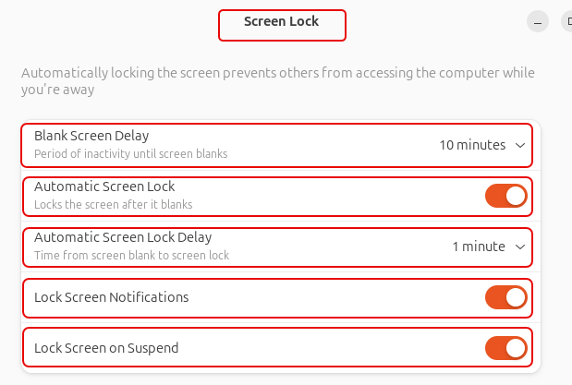Set “**10 minutes**” blank screen delay
  3. Automatic Screen Lock **ON**
  4. Automatic Screen Lock delay **1 minute**
  5. Lock Screen notifications **ON**
  6. Lock Screen on Suspend **ON**

* 1. Click on “**Diagnostic**”

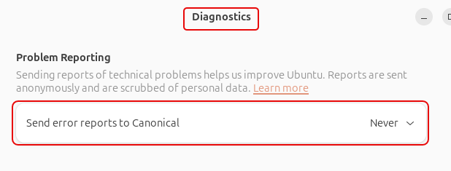

* + 1. Set error reports to Canonical to “**Never**”

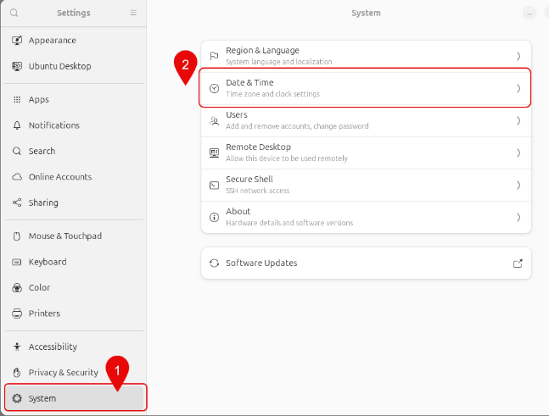

1. Click “**System**”
   1. Click on “**Date & Time**”

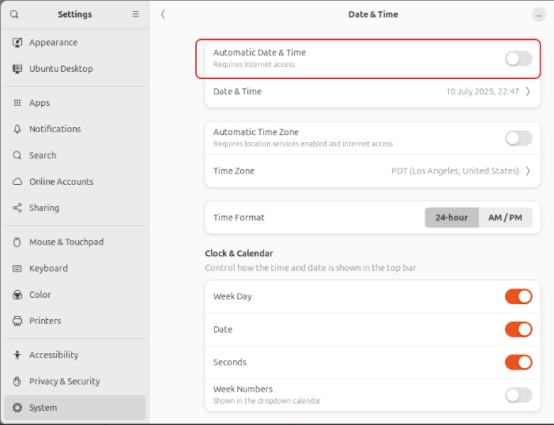

* 1. Disable “**Automatic Date and Time**”

1. Right click on Desktop and under "**Arranged By…**” select “**Keep Arranged…**”

1. Right click on Desktop and select “**Open in Terminal**”
2. Disable automatic updates && upgrades
   1. sudo dpkg-reconfigure -plow unattended-upgrades
   2. sudo systemctl disable apt-daily.timer apt-daily-upgrade.timer

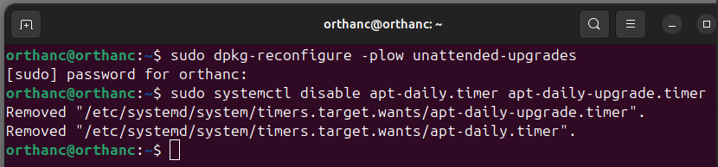

* 1. sudo apt remove --purge -y unattended-upgrades

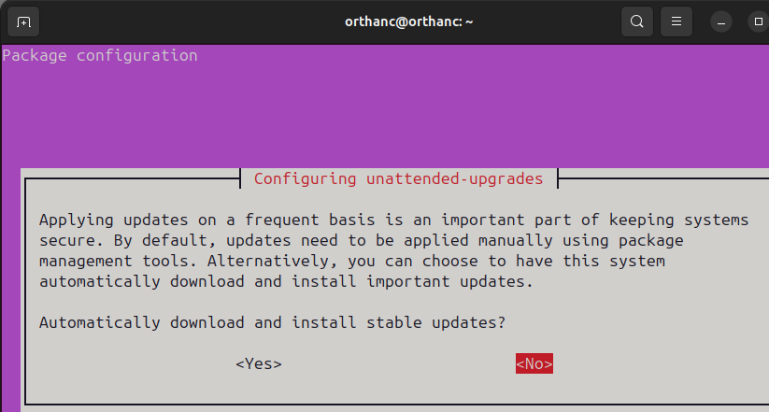

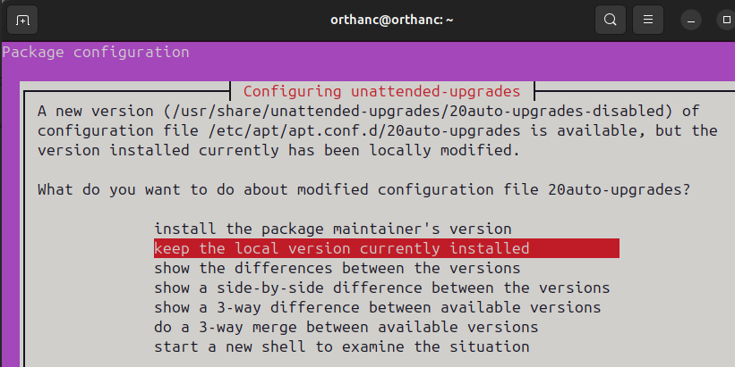

* 1. gsettings set com.ubuntu.update-notifier no-show-notifications true

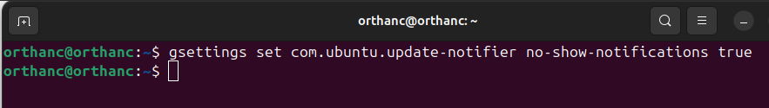

1. Set background to plain gray
   1. gsettings set org.gnome.desktop.background picture-uri none
   2. gsettings set org.gnome.desktop.background primary-color gray

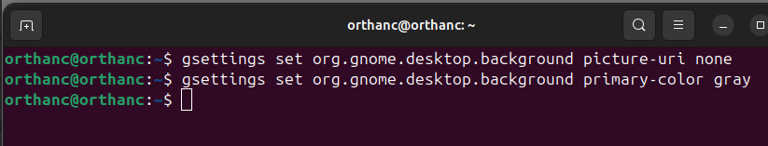

1. 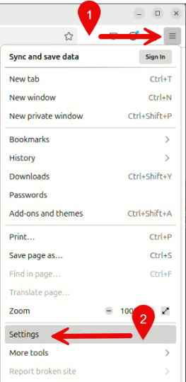Configure the installed firefox
   1. Launch Firefox browser
   2. Click on “**Burger**” icon
   3. Click on “**Settings**”
   4. 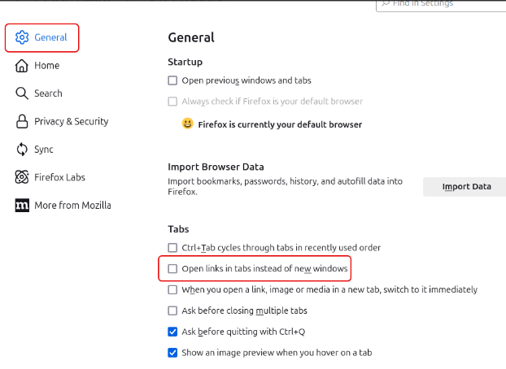Click on “**General**”
   5. Uncheck “**Open links in tabs instead of new windows**”
   6. Click on “**Home**”

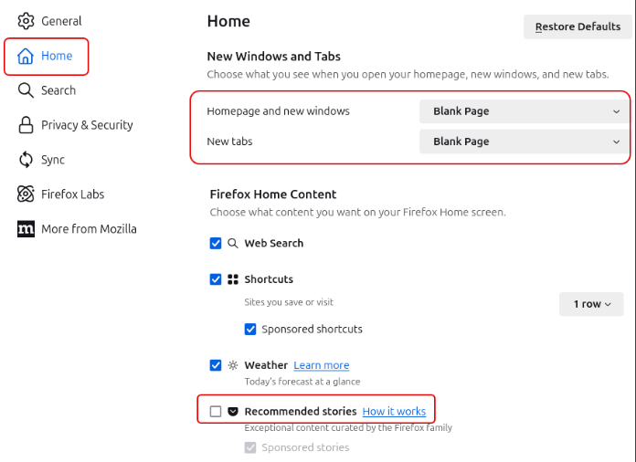

* 1. Set Homepage as “**Blank Page**”
  2. Set New tabs as “**Blank Page**”
  3. Uncheck “**Recommended Stories**”

1. Enter http://localhost:8042 in Firefox and bookmark it.

NOTE: *You should have connected with the running Orthanc server.*

## A screenshot of a computerUpdate GDM changes

1. Right click on desktop and select “**Open in Terminal**” to access terminal window
2. Change directory to tmp

orthanc@orthanc: cd /tmp

1. Download 1010_upgrade.tar package
   1. orthanc@orthanc: wget <https://feralsw.com/cdw/1010_upgrade.tar>
2. Extract the 1010_upgrade.tar file

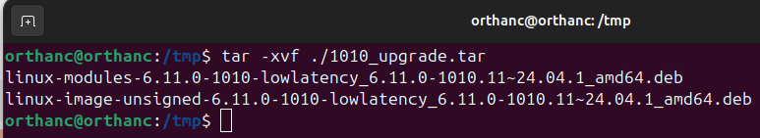

1. Add/update debian packages

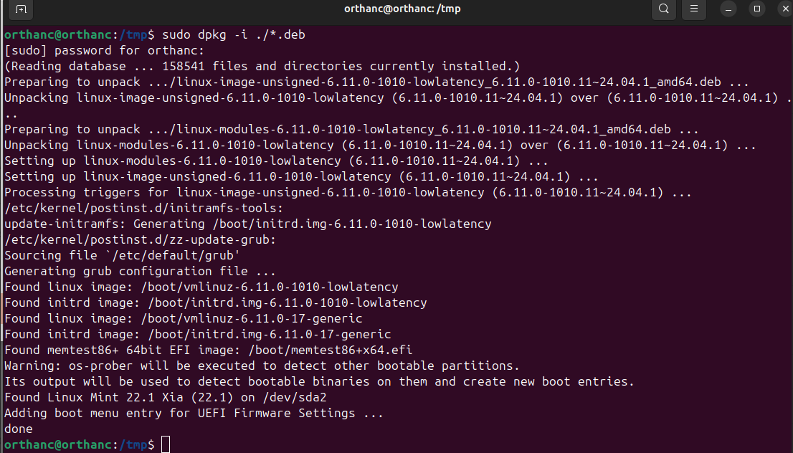

1. A screenshot of a computer

   AI-generated content may be incorrect.Install GDM setting interface
2. 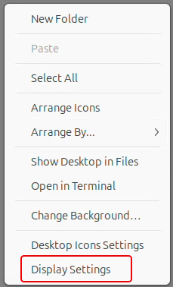Right click on desktop and select “**Display Settings**”

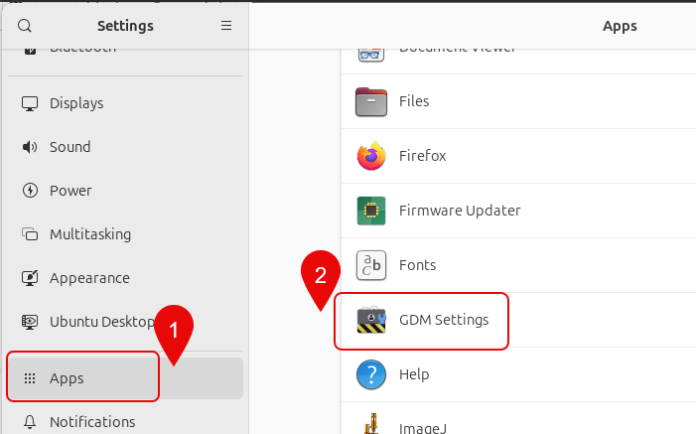

1. Select “**Apps**”
2. Click on “**GDM Settings**” icon
3. 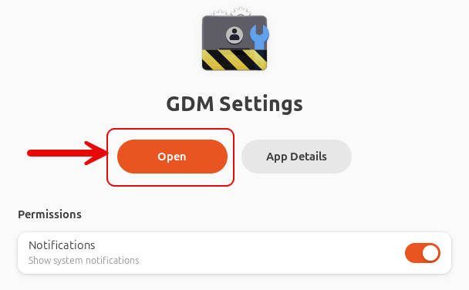Click “**Open**” to access settings window
4. 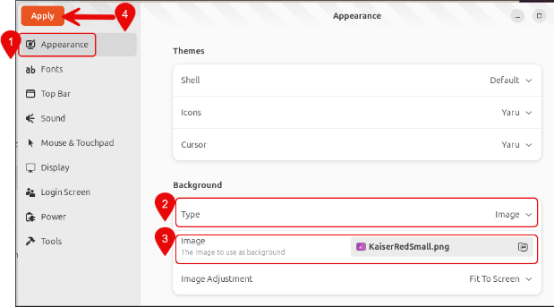Select “**Appearance**”
   1. Change Type to “**image**”
   2. Add **/usr/lib/kp-report/KaiserRedSmall.png** as the “image”.

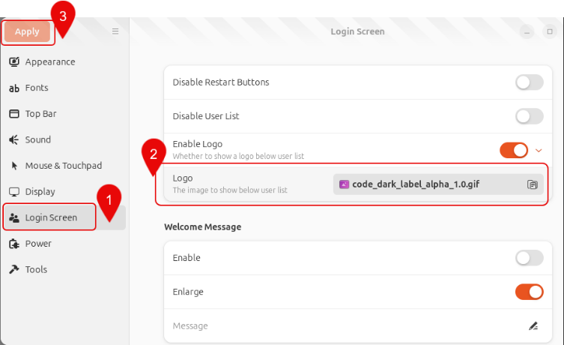

1. Select Login Screen
   1. Click “**Login Screen**”
   2. add **/usr/lib/kp-report/code_dark_label_alpha*.gif** as the image
   3. Click “**Apply**” to save changes

* Process to create a Code Dark USB is completed.
* Restart the machine
* select USB from the boot menu to reboot in UBUNTU installed on the USB